HRGS
(HIGH RESISTANCE GROUNDING SYSTEMS)

Öz Direnç HRGS uses resistors to protect the plant's entire electrical grid from catastrophic ground faults.

Öz Direnç High Resistance Grounding System (HRGS) is used in continuous-process industrial plants where a sudden electrical shutdown would cause massive financial losses, unsafe conditions, or damaged product.

It is installed in electrical substations between the neutral point of a transformer (or generator) and the earth ground.
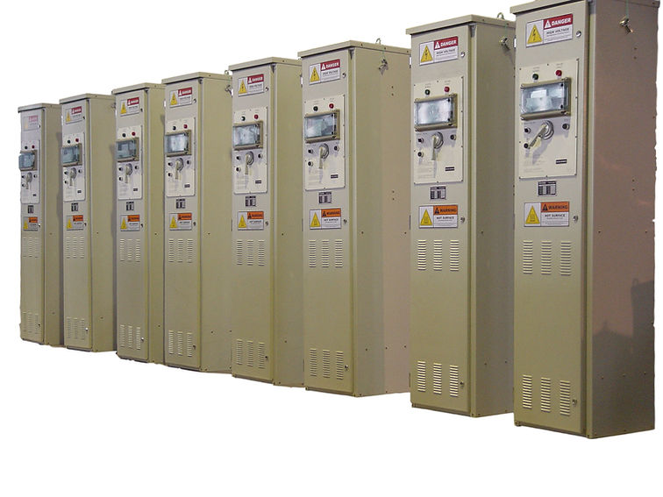
- Data Centers & Server Facilities
- Oil, Gas & Petrochemical Refineries
- Semiconductor & Microchip Manufacturing
- Pulp, Paper & Textile Mills
- Food & Beverage Processing Plants
- Hospital & Healthcare Critical Grids

Öz Direnç, has more than 25 years of experience in delivering highest quality power resistors to its clients worldwide.

​The manufacturing facility in Turkey is certified to ISO 9001/ ISO 14001/ OHSAS 18001. Öz Direnç has strong presence through authorized partners in Bulgaria, Indonesia, Iraq, Morocco, Philippines, Thailand, United Kingdom and USA.

LOADBANKS

Loadbanks are resistors for loading gensets or other power sources so that they can be tested to ensure they can deliver their rated power in actual loading conditions.

- Factory testing of Diesel Gensets,
- Periodic exercising of stand-by engine Gensets,
- UPS System testing​
- Battery System testing
- Aviation Ground Power Unit (GPU) Testing
- Load optimization in prime power applications
- Remove and prevent carbon-buildup on piston heads
Aviation Loadbank 28 VDC GPU Tester
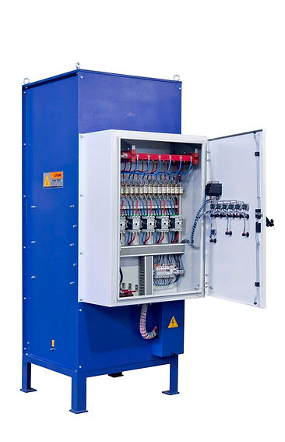
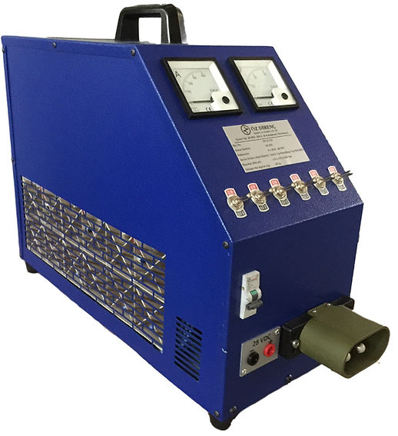
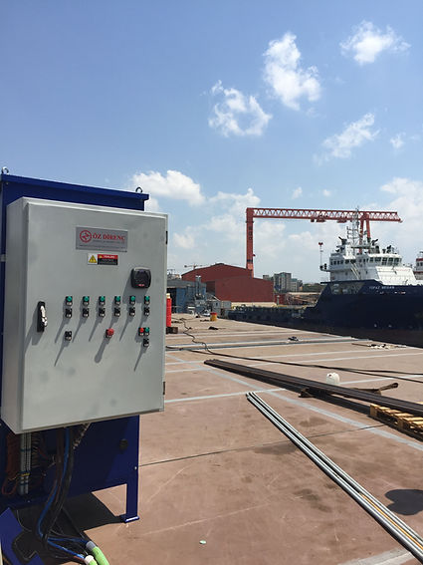

400 V Loadbank 300 kW
300 kW Loadbank at Shipyard

MOTOR STARTING

Our resistor units are widely used in motor control applications where electronic drive systems become inadequate due to severe operating conditions having heavy vibration, very high ambient temperatures, dust and humidity as the prime parameter of design.

Start resistors are used in conjunction with switch-starters or contactors for starting and speed regulating of AC slipring motors as well as DC motors.

Contrary to popular belief, starting resistors are still used widely in heavy industries such as

- Iron and Steel Mills
- Cement Plants
- Mining.

Since our inception, Öz Direnç has been totally focused on designing and building tough, durable and reliable resistors.
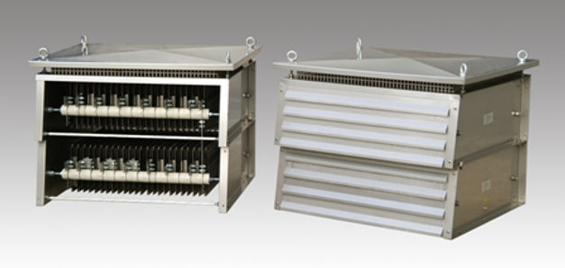

NEUTRAL GROUNDING RESISTORS

The neutral of the transformer or generator is connected to ground through a Neutral Grounding Resistor (NGR) to limit phase-to-ground fault currents.The reasons for limiting the current, in case of a line-to ground fault, are the following:

- To reduce burning and melting effects in faulted electric equipment, such as switchgear, transformers, cables, machines.
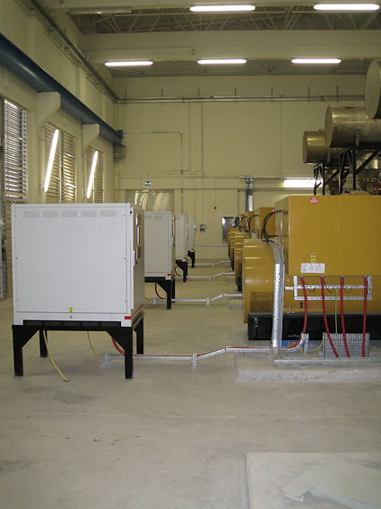
- To reduce mechanical stresses in circuits and apparatus.
- To reduce electric-shock hazards to personnel.
- To reduce the arc blast or flash hazard to personnel.
- To reduce the momentary line-voltage dips.
11 kV Generator NGR
- To secure control of transient overvoltages

Resistance grounding may be either of two classes, high resistance or low resistance,distinguished by the magnitude of ground-fault current permitted to flow.
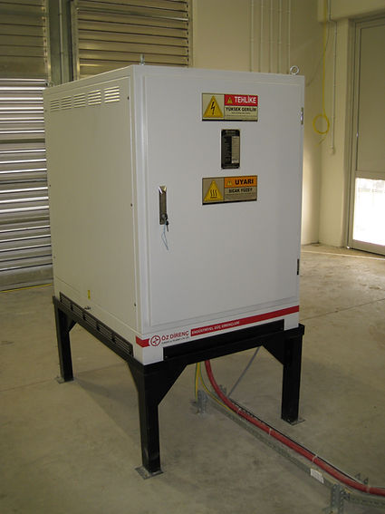

- Power Generation & Utilities
- Renewable Energy Plants
- Mining, Quarrying & Mineral Processing
- Marine Vessels & Offshore Oil Rigs
- Oil, Gas, and Petrochemical Refineries
- Heavy Manufacturing & Process Industries

OIL-COOLED STARTER

Oil-cooled starters (also called oil-immersed starters) are used in heavy industries, mining, and agriculture to safely start massive electric motors that pull immense electrical current.

They are specifically chosen for harsh environments, heavy starting loads, or areas prone to severe voltage fluctuations:

- Heavy Industrial Conveyors & Material Handling
- Mining & Cement Plants
- Industrial Pumps & Fluid Handling
- Agriculture & Remote Farming Irrigation
- Large Compressors & Fans
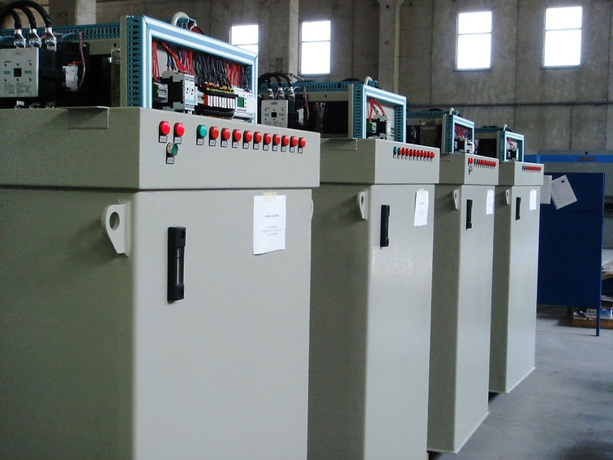
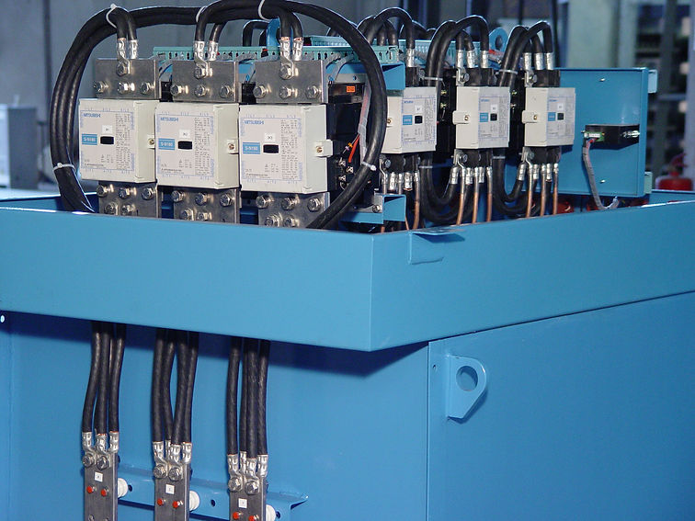

Oil-Cooled Starter 800 kW
Automatic Air-Cooled Starter

Since our inception, Öz Direnç has been totally focused on designing and building tough, durable and reliable resistors.

